The Big disclaimer:
I have put all this information together from my own notes and from clips of others who have bin kind enough to share there idea’s with. Please use good common sense when looking through these notes. There are no rules here only a place where these ideas can be pooled together. No guarantee warrantees or endorsements should be assumed. This Is a work in progress and I apologize in advance for my typos and miscommunications. There are numerous tips that were taken out of context to fit in this document I hope no one will be upset with Lack of “” and foot notes. Thanks to all who participated and keep those Tip and trick for Zak’s rolling in.
Regards, Bruce

Every Bike Manufacture has it unique characteristics. Bikers are unique as well. Striving for perfection many of use have devised Tips and tricks to make our bike riding experience more enjoyable. Here are a few:

Tips and Tricks:
rev 1 10/12/01

Bruce,
Here are a couple I have used on my Leprechaun:
1. Mt. Mirrorcycle mirror mounts perfectly in the handlebar end - just
remove the rubber plug and install.
2. A Chronometro knob mounted on the derailleur post holds a computer in an
easily visible position. Point the knob to the left and you'll avoid
clearance issues with the derailleur.
3. I clipped a Vistalite headlamp unit upside down under the left handlebar
. The mount for the stick battery fits onto the water bottle bosses under the
maintube just in front of the chainstays and the coiled cord reaches the
light easily.
4. You can mount a taillight to a piece of alum. stock bent at right angles
and drilled to fit to the bolt that secures the seat brace to the frame. I'm
also looking at installing an MTB Bar-end at the top of the LH seat back
frame so that I can mount a taillight up high.
5. More seat recline is available if you remove the fixing bolt, lower the
seat, then drill out the inside tube of the seat brace through the holes in
the outside tube. Then re-install the bolt.
Editor comment. By the way on your point number 5, I have some important info: I earlier made an inquiry to Bill Haluzak about reclining the seat it the manner you suggested. He recommended against it because he felt the increase in angle went beyond the safe stress level of the seat post design. He recommended using two seat stays from the seat back too the rear wheel fork. this would give the strength need but it would also make the ride more ridged and possibly less comfortable. I have not tried this As I decided to work on the engine --BE
6. If you're traveling light, the little tool pouch sold by Nashbar Velcro’s
with its own straps nicely to the horizontal seat back brace.
7. To carry more, a Blackburn or Schwinn standard MTB rear rack fits easily.
Just use the long braces that come with the rack, and fasten to the vertical
seat brace with any kind of bracket. I used an old headlight mounting
bracket.
8. Don't bother with the Haluzak seat bag unless you like a relatively
upright position. Mine rubs the rear tire on either of the two lowest
positions that come stock on the bike unless I have the rack installed.
Tom Thompson
'00 Haluzak Leprechaun

Quick Draw bottle
I have found a way to fasten two water bottles to the back of the seat and still be able to
access them while riding.
I mounted a Minoura bottle cage holder on the main vertical seat tubes (each side). The Minouras can also be rotated to mount to horizontal tubes. That is what I used to fasten a Nashbar handle bar bag to. But that is another story. After mounting the Minoura's
on the side tubes I used a Performance Quick Draw bottle cage on each holder. The Quick Draw cages do not have a top piece to hold the bottle in. It is not necessary and in this application would be a problem. Also avoid the cages that have a rubber band around
them because they squeeze the bottle too tightly.
The Quick Draw cages hold the bottle fine but allow easy access in and out by reaching around the back of the seat while still riding. I can hit the cage at an angle when replacing a bottle and the cage funnels the bottle right in. It takes a little practice but quickly becomes easy. Trick is to mount the cages low so the arm does not have to be raised a lot when reaching. Also it will help with the center of gravity. The bottles are behind the seat enough to be aero.
DON
__________________________________________________
MORE Water Ideas by Bruce.
I chose to put an old Cannondale water bottle cage on the front of my bents These are not really cages but rather a hard plastic frame with a Velcro curved platform which the Velcro covered bottles stick on. I don’t know if they still make these but they work great! You don’t have to slide the bottle in from the front, which is difficult, if you’re new to riding a bent . This way you can just slap the water bottle down and it stays. I put some wide Velcro on the side of my cheep regular bottles so they can still be used in a regular cage.
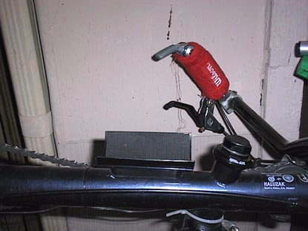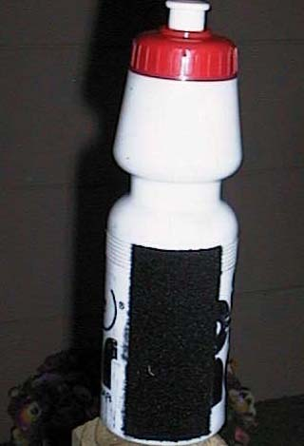

The Hybrid Race has a set of brazon on the rear stays. I decided I wanted to use these for a second water bottle. This is not straightforward proposition as they are on the inside facing the wheel. I took a piece of angle aluminum from old window frame and taped it out for screws that fit a standard water bottle cage. On the right side of this angle iron I drilled two holes to match the brazon on the bike. Now I have a low (center of gravity) easy to reach water bottle. See picture.
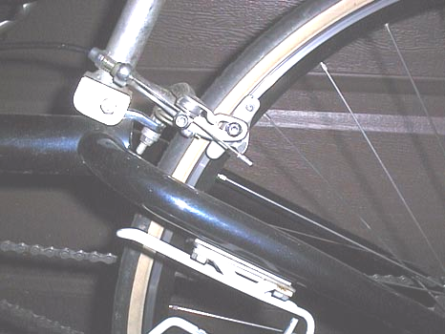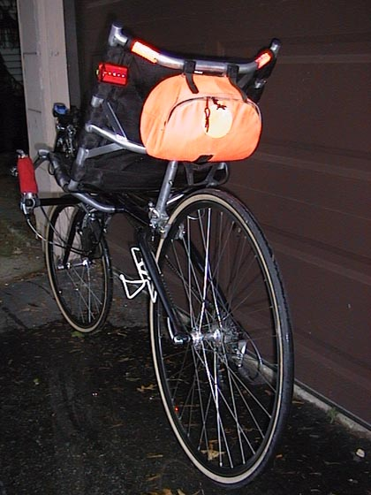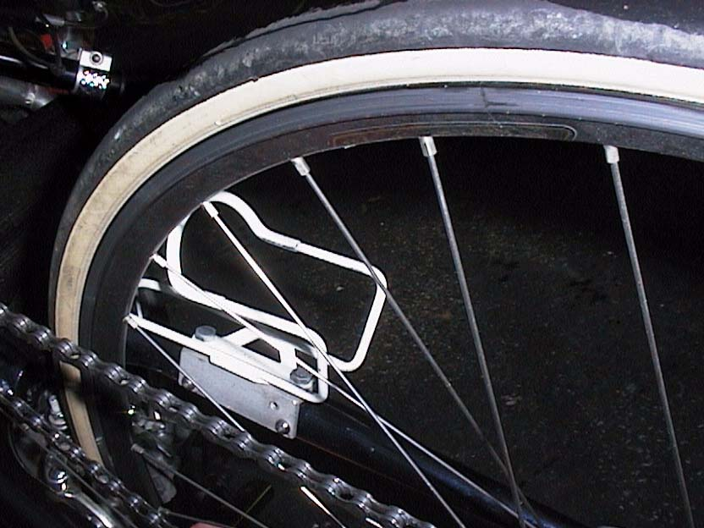

The best choice is probably the Camel back on back of the seat option. MY wife found this the easiest way to ride and hydrate. I did not like the way the drinking tube had to be attaching to your shirt in order to keep it handy. I routed the tube down along the side of the seat. I took some dental floss and firmly bound the tube clamp clip to the frame just where your hand would be when you take it off the pistol grip. A few Velcro straps keep the tube tight to the frame and out of the way of the rear wheel if you should accidentally let it go. See pictures
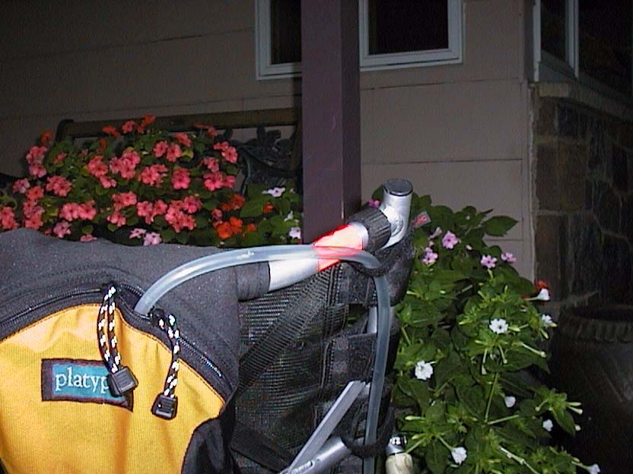

How to keep you hand cool and dry:
I used a tennis sweatband to cover the pistol grips they absorb the sweat and feel great. I cut one band in half after sewing it up the middle and made 4 grips from one pair.
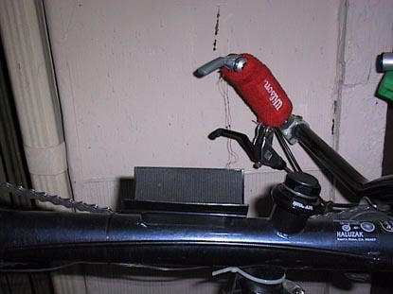

The greasy leg problem:

The easy fix for this is a simple chain guard, just where you need it. I fixed a short piece of plastic tubing to the roloflex roller with a couple of zip ties. I used a hard plastic tube that the use to run fiberoptic cable in, but any stiff tubing like what you might find at home depot for irrigation would work. A 2 inch diameter tube cut in half about 10 inches long will due. Drill two holes one on each side of metal mount for roloflex ( see Pict.) the zip ties secure the half tube over the area of the chain that get you grease. A dab of silicon on the cut zip tie ends makes them friendly.
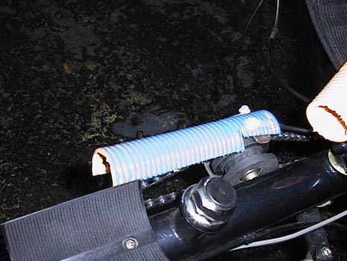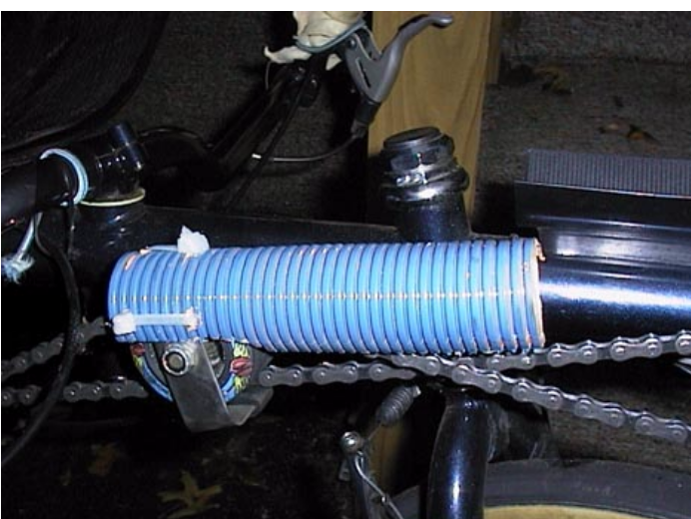

Be sure to cover the zip tie end they are sharp! I used some silicone on them.

Questions and some answers:

1.
----- Original Message ----- From: bruce To: derek@sonic.net Sent: Monday, March 12, 2001 3:48 PM Subject: tires?
Hi Derek,
I saw your posts on the recumbent news group and though you might have a good feel for what I looking for. I have a Haluzak hybrid race with a 20 1/18 front wheel (451 I guess) I will be needing a set of tires soon and realize there is not much choice for the front tire. I was hoping you would have an option as to what would be a top of the line road tire in this size. Your comment s will be appreciated.
Bruce,
The fastest tire available would be the IRC 451 nylon wound Road Lite EX. I personally would prefer the Primo Comet Kevlar 37/451 tire, or even perhaps the 47/451 size for your particular bike depending on whether you have a front shock or not. If no shock, go for the wider size tire because Haluzaks have a heavily loaded front wheel. Inflate the Primo's to 110 PSI and they will roll almost as fast as the IRC with far better handling characteristics. If you need more flat resistence than a Primo Comet, I believe Schwalbe makes a City Marathon Kevlar belted tire in the 451 size that is a very tough but is a slow tire. You can get these tires from Zach Kaplan via mail order. Good luck!
Cheers,
Derek

Bruce,
It occurred to me that other 'Zak owners, especially those w/ HHRs w/ 451front wheels might like to know that a good source for tires for 20" wheels, and especially for 451 wheels is
Bike Friday. Their web site at the following
URL shows a good variety of appropriate tires and tubes.
http://www.bikefriday.com/gearcatalog3.cfm?Page=1

2.Queston:
I have a new Leprechaun by Haluzak being short 5’2 I have Tried to move the pistol grips to a upright position to make the reach more comfortable since there is no handle bar stem to be adjusted. The problem is that the grips hit the seat limiting the turn radius and the bike become unstable when trying to make very slow tight turns. When you cant turn the wheel far enough in a tight turn you find your self on the ground feeling inapt. I tried every permutation of handle bar adjustment to try to correct this problem but only the original configuration with the pistol grips tilted forward will allow for the correct range of motion on the front wheel. I can see that a wider handle bar would increase the range enough to move the grips up the upright position if I can find such a thing. I am looking for solution to adjust the reach and give me the tight turning radius I need. Any suggestion Welcome? Thanks

Possible answer- The seat is joined by a coupler in the middle if you drill out the pop rivet and take the seat apart you can cut off just a little from each side ( 1/8 or ¼ inch) reassemble the seat, effectively making the seat a touch more narrow this would give more turning room.

Possible answer: find handle bars that are wider and have more sweep to the rear (or more rise).This would solve the problem for those with short reach. Making the bars hit further back on the seat giving more turning radius – If any one knows of such handle bars please let us know!

3. Question:
How do you get rid of the seat squeak?
Answer: According to the Haluzak shop; One could take the seat apart and lubricate the joints or tubing that slides together with Cosmoline which Is some type of preservative that you might find at a gun shop. I did try dripping some bike oil in to the joints with some success but the squeak comes back.
(Cos·mo·line (k¼z“m…-l¶n”). A trademark used for a rust and corrosion preventive compound of petrolatum.)

4. What kind of pedal system do you like?

5. Any body think a faring is worth the trouble on your Zak?

